**LAB 3**

**3.1 Take input of two numbers then calculate their sum, difference, product and quotient then output the result**

**SOURCE CODE**

**#include <iostream>**

**using namespace std;**

**int main()**

**{**

**float a,b,c;**

**cout<<"Enter two numbers"<<endl;**

**cin>>a>>b;**

**c=a+b;**

**cout<<a<<"+"<<b<<"="<<c<<endl;**

**c=a-b;**

**cout<<a<<"-"<<b<<"="<<c<<endl;**

**c=a*b;**

**cout<<a<<"*"<<b<<"="<<c<<endl;**

**c=a/b;**

**cout<<a<<"/"<<b<<"="<<c<<endl;**

**return 0;**

**}**

**OUTPUT**

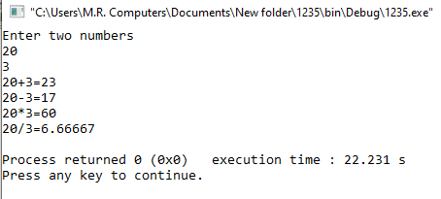

**3.2 Take input for the radius of a circle then calculate its area, circumference and diameter, then output the three results.**

**(Area= π r2 circumference=2πr diameter=2r)**

**SOURCE CODE**

**#include <iostream>**

**using namespace std;**

**int main()**

**{**

**float R,B;**

**cout<<"Enter radius of circle"<<endl;**

**cin>>R;**

**B=(R*R)*3.15;**

**cout<<"Area of circle is "<<B<<endl;**

**B=2*3.14*R;**

**cout<<"Circumference of circle is "<<B<<endl;**

**B=R/2;**

**cout<<"Diameter of circle is "<<B<<endl;**

**return 0;**

**}**

**OUTPUT**

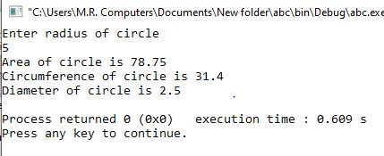

**3.3 Write a program that swaps values of two variables using a third variable.**

**SOURCE CODE**

**#include <iostream>**

**using namespace std;**

**int main()**

**{**

**float a,b,c;**

**cout<<"Enter first number"<<endl;**

**cin>>a;**

**cout<<"Enter second number"<<endl;**

**cin>>b;**

**cout<<"Before swap first number is "<<a<<endl;**

**cout<<"Before swap second number is "<<b<<"\n\n"<<endl;**

**c=a;**

**a=b;**

**b=c;**

**cout<<"After swap first number is "<<a<<endl;**

**cout<<"After swap second number is "<<b<<endl;**

**return 0;**

**}**

**OUTPUT**

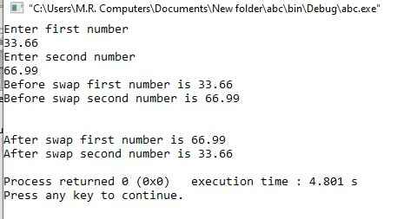

**3.4 A program that inputs an 8 digit binary number then converts it in Decimal. (Use of % operator, POW () function)**

**SOURCE CODE**

**#include <iostream>**

**#include <cmath>**

**using namespace std;**

**int main()**

**{**

**int A,B,C,D,E,F,G,H,ANS;**

**cout << "Conversion of Binary to decimal\n" << endl;**

**cout << "Convert 11010101 into decimal number system\n" <<endl;**

**A=1* pow (2, 0);**

**B=0* pow (2, 1);**

**C=1* pow (2, 2);**

**D=0* pow (2, 3);**

**E=1* pow (2, 4);**

**F=0* pow (2, 5);**

**G=1* pow (2, 6);**

**H=1* pow (2, 7);**

**ANS=A+B+C+D+E+F+G+H;**

**cout <<"11010101 in Decimal number system is \a"<<ANS<<endl;**

**return 0;**

**}**

**OUTPUT**

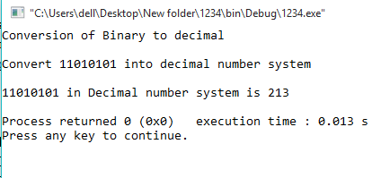

**3.5 write a program to convert dollar into rupees (1$= Rs.139)**

**SOURCE CODE**

**#include <iostream>**

**using namespace std;**

**int main()**

**{**

**float a,b;**

**cout<<"Enter Amount in dollars"<<endl;**

**cin>>a;**

**b=a*165.5;**

**cout<<"\n2Amount in Pakistani rupees is "<<b<<endl;**

**return 0;**

**}**

**OUTPUT**

